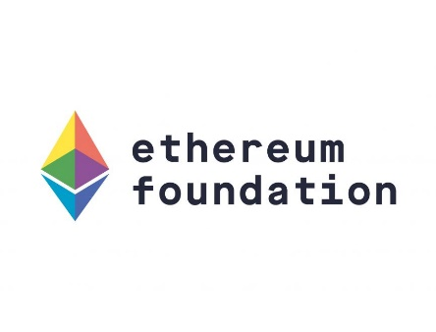 

Formally verified Ethereum 2.0 Beacon Chain

Funded by: Ethereum Foundation

Principal Investigator: Dr. Hamra Afzaal

Department of Computer Science

Information Technology University of the Punjab

Lahore, Pakistan

Formally verified Ethereum 2.0 Beacon Chain

Funded by: Ethereum Foundation

**Project Team:**

Principal Investigator: Dr. Hamra Afzaal

Co-Principal-Investigator: Dr. Muhammad Imran

Dr. Muhammad Umar Janjua

Research Associates: Aqsa Tehseen

Shaheen Kousar

Sheeza Batool

MS Students: Muhammad Rashid

Imran Rasool

Consultant: Prof. Dr. Nazir Ahmad Zafar

Department of Computer Science

Information Technology University of the Punjab

Lahore, Pakistan